EU DECLARATION of CONFORMITY

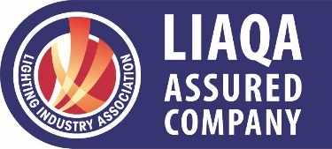
KSR Lighting Ltd

Optimum House, Beeding Close
Southern Cross Trading Estate
Bognor Regis, West Sussex, PO22 9TS

Declares that under our sole responsibility the Product Range

Vito Ground Recessed Fittings – KSR99130, KSR99131 & KSR99132

is in conformity with the provisions of the following EU directives and regulations, including all amendments, and with national legislation implementing these directives:

LVD Low Voltage Directive 2014/35/EU
EMC Electro Magnetic Compatibility Directive 2014/30/EU
ERP Energy Related Products Directive 2019/2020/EU
RoHS Restriction of Hazardous Substances 2015/863/EU

The following harmonised standards have been applied

EE(S) R
BSEN60598-1:2021+A11:2022 | Luminaires – Part 1: General requirements and tests
BS EN IEC 60598-2-1:2021 | Luminaires. Particular requirements. Specification for fixed general purpose luminaires
BS EN 62493:2015+A1:2022 | Assessment of Lighting Equipment Related to Human Exposure to Electromagnetic Fields
RoHS
BS EN 63000 | Technical documentation for the assessment of electrical and electronic products with respect to the restriction of hazardous substances
EMCD
BS EN 61547:2009 | Equipment for general lighting purposes. EMC immunity requirements
BS EN 55015:2013+A1:2015 | Limits and methods of measurement of radio disturbance characteristics of electrical lighting and similar equipment
BS EN 61000-3-2:2019+A1:2019 | Electromagnetic compatibility (EMC). Limits. Limits for harmonic current emissions
BS EN 61000-3-3:2013+A2:2021 | Electromagnetic compatibility (EMC). Limits. Limitation of voltage changes, voltage fluctuations and flicker in public low-voltage supply systems

Authorised signatory:


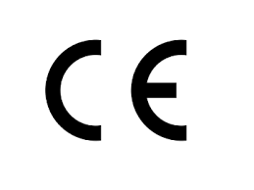
Name: Jon Callander
Position: Managing Director
Date: 25/07/2024
Place of issue: As above

